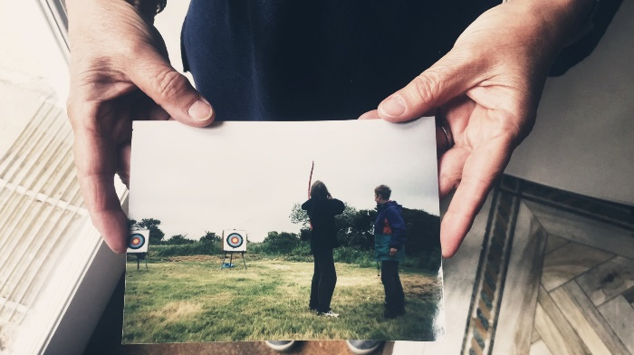
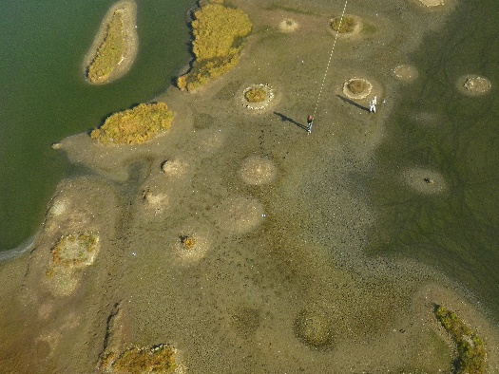
PhD Studentship

Title: African Identities and the Transatlantic Slave Trade and Slavery in the Eighteenth and Nineteenth Centuries.
Closing date: 10th June 2024
Interview date: w/c 8th July 2024

Supervisory team

Director of Studies: Professor Suzanne Schwarz, School of Humanities, University of Worcester.
Supervisor: Professor Paul E. Lovejoy, York University.

The Project
Applications are invited for a fully funded, full-time PhD studentship for the project ‘African Identities and the Transatlantic Slave Trade and Slavery in the Eighteenth and Nineteenth Centuries’.
Context
Between the mid sixteenth and mid nineteenth centuries, an estimated 12.5 million Africans were forcibly shipped as a slave labour force to various destinations in the Americas including North America, Brazil, Cuba, and the Caribbean. For the overwhelming majority of individuals transported in the trade, there is little evidence about their identities and experiences. A recent report by UNESCO emphasises the dehumanisation which characterised the slave trade and slavery. In this context, retrieving information on African lives is vital to developing a fuller understanding of the human impact of the Atlantic slave trade and its legacies. This approach makes it possible to move beyond the bare statistics of numbers transported and to see the effects of a trade declared by the United Nations in 2010 as a ‘crime against humanity’. The importance of understanding the history, as well as the profound cultural legacies, of this global African displacement, is emphasised not only through Black Lives Matter but also in the UN General Assembly’s proclamation that 2015 marked the beginning of the International Decade for People of African Descent.
This studentship offers an exciting opportunity to use extant archival sources to reconstruct the life histories of individuals uprooted and displaced in the transatlantic slave trade. There is scope to retrace individuals and their identities and experiences in various geographical settings, including West Africa, Brazil and the Caribbean. This research project is closely linked to two major digital humanities initiatives entitled ‘Freedom Narratives’ and ‘Liberated Africans’. The successful candidate will have the opportunity to contribute to the autobiographical testimonies and life histories in ‘Freedom Narratives’, a database that focuses on ‘the enforced migration of enslaved Africans in the Atlantic World during the era of the slave trade’.
Aims and Objectives
This research project will reconstruct and analyse the life histories of individuals who were forcibly exported from Africa in the transatlantic slave trade in the eighteenth and nineteenth centuries. This involves using archival sources to re-trace their subsequent life histories and experiences in a variety of geographical contexts including West Africa, the Caribbean and Latin-America.
Indicative methodology
This research project involves using a wealth of manuscript and printed evidence surviving in archives in Britain, West Africa, the Caribbean and Latin-America. Depending on the geographical focus of the research agreed with the supervisory team, there is a large body of evidence relevant to this research proposal that has already been digitised through a series of British Library Endangered Archives Major Awards.
References
Paul E. Lovejoy, Henry B. Lovejoy, Érika Melek Delgado, Kartikay Chadha, eds., Regenerated Identities: Documenting African Lives (Trenton: New Jersey: Africa World Press, 2022).
Suzanne Schwarz, ‘Reconstructing the Life Histories of Liberated Africans: Sierra Leone in the Early Nineteenth Century’, History in Africa, 39 (2012), pp. 175-207;
Freedom Narratives: https://freedomnarratives.org/
‘Liberated Africans’ https://Liberatedafricans.org
Equiano’s World: https://equianosworld.org

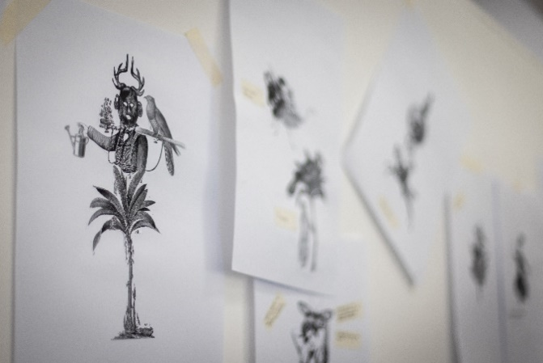
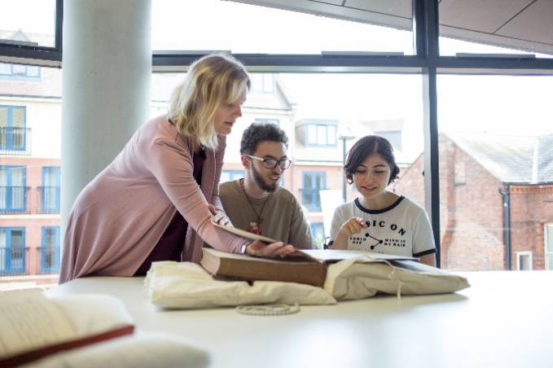
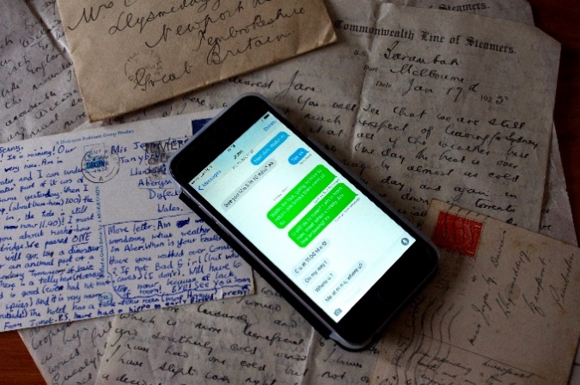
Details of the studentship

The studentship is offered for a 4-year period on a full-time basis. The studentship is campus based. During the period of your studentship, you will receive the following:

- a tax-free bursary of £17,688 for 3 years
- a fee-waiver for 4 years (expectation that full time students complete in 3 years. If student enters year 4, the bursary stops but fees are waived)
- a budget to support your direct project costs including dissemination costs
- a laptop and other IT equipment and software as appropriate to the project
- use of the Doctoral School facilities

You will be expected to play an active role in the life of both the Doctoral School and of your academic School. You will be given opportunities to gain experience in learning and teaching within the School under the guidance of your Director of Studies. There will also be the opportunity to work with local museums.

Application Process

To begin the application process for this studentship please go to Doctoral School PhD Studentships and click ‘apply now’ next to the project you wish to apply for.
It is expected that applicants will have the following qualifications:

- A Masters in the area of History or Medical History or equivalent professional experience.
- A First or Upper Second Honours Degree

It is also expected that applicants will be able to demonstrate the following:

- A sound understanding of and interest in both the project and the wider subject area
- Experience of relevant research methods and skills
- Ability to contribute to the research design of the project
- Proficiency in oral and written English
- Proficiency in IT relevant to the project
- Ability to organise and meet deadlines
- Good interpersonal skills
- Ability to work independently
- Ability to work as part of a team

The Interview

The interview will provisionally be held on Teams on the w/c 8th July 2024. Shortlisted candidates will be given at least 7 day’s-notice of interview. As part of the interview and selection process, you will be asked to write a short reflective review of a journal article. You will be advised about the subject matter of this review if you are selected for interview. Alongside the interview, shortlisted candidates will also be asked to give a 10 minute presentation on a related topic.

Research at the University of Worcester

Research at the University of Worcester has grown significantly over the last 10 years. The outcomes of the Research Excellence Framework 2014 (REF 2014) showed that Worcester was the most improved University in the UK based on Research Fortnight’s “Research Power” measure. The University’s continued progress was shown in the outcomes of REF 2021 which demonstrated that both the scale and quality of our research has further increased, with over 40% of our research recognised as world-leading or internationally excellent.

The University has been successful in winning funding from a wide range of major funders: Research Councils such as AHRC, BBSRC, ESRC and NERC; major charities such as the Leverhulme Trust, the Alzheimer’s Society and the British Academy; health-research funders such as the NIHR, the Department of Health and local NHS Trusts; European funding through Horizon 2020 and Erasmus+; and funding from local, national and global businesses.

The University is focused on research which addresses real world challenges and provides solutions to these challenges:
- Human Health and Wellbeing
- Sustainable Futures
- Digital Innovation
- Culture, Identity and Social Exclusion
- Professional Education

The University continues to provide a robust infrastructure for research. It has a well-established Doctoral School which houses its growing research student body and which provides a comprehensive programme of researcher development for staff and students. It has a well-established Research Office, responsible for research funding, governance and strategy. The University is committed to further developing its research profile, through a strategic approach to its support for and investment in research. Its fully-funded studentships are part of this investment.

Doctoral School

The Doctoral School is a focal point for all our research students. It provides:
- day-to-day support for our students, both administrative and practical, through our dedicated team
- a Research Student Study Space with both PCs and laptop docking station
- a comprehensive Researcher Development Programme for students and their supervisors
- a programme of student-led conferences and seminars

School of Humanities
Humanities at Worcester encompasses subject areas including English, Media and Culture, History, Sociology, Politics, Law and Criminology.
As an academic community, we are ambitious for our achievements and their impact upon individuals’ lives and career prospects. We place a great value on the individual and creating a friendly and supportive environment in which to work and learn.
By sharing our academic work and collaboration with partners, we aim to make a distinctive contribution to public life in the region, and to international knowledge in our academic subjects. Dynamic interaction with associated professional worlds underpins the day-to-day environment in which learning, teaching and research take place.
We are a community of historians, theorists and practice-led researchers.
Research processes are fundamental to the work and development of our undergraduate and postgraduate students, whose teaching is enriched by the research activity and interests of doctoral and postdoctoral researchers, all of whom are also experienced and committed teachers.
Our academics regularly achieve national and international peer recognition for their contributions to knowledge, and we are committed to sharing the outcomes of their work publicly, and engaging in knowledge transfer, to the benefit of communities within our region. Much of our activity involves partnerships with colleagues based in other universities and with professional organisations and companies.
Our research in English Studies ranges from original poems and performances, to literary criticism and cultural theory, to ethnographic language studies and computer-assisted linguistic analysis. Striving for excellence in all areas therefore entails the celebration of diversity in ‘English Studies’, and a commitment not only to pure subject specialisation, but also to the interdisciplinary work which challenges traditional boundaries.
Historical research in the School spans early modern Britain, pre-colonial West Africa, and modern Britain, Ireland, and the USA. Areas of thematic strength in research include gender, imperialism, slavery, political culture, and religious history.
Widening Participation
As part of its mission statement the University is committed to widening participation for its higher degrees. Although most candidates will have an undergraduate and/or a Masters degree, the University is happy to accept applications from candidates with relevant professional qualifications and work related experience.

For further information or an informal discussion on this project, please contact Professor Suzanne Schwarz (Director of Studies) via email at s.schwarz@worc.ac.uk
Applications can be made at:
UW Doctoral School PhD Funded Studentships

