Principles for Lesson Design

Overview
Designing lessons should be considered as a process rather than a product. Much of this complex, layered process is inherently invisible as it requires hard thinking. Individual lesson plans are the product of this thinking and design process – they provide a useful tool that can be used as an aide-memoire by you and as the basis for professional discussion between you and your mentors. As you become more experienced you will find the process develops in terms of the speed with which you can design a lesson (or sequence of lessons). Additionally, your understanding of how to incorporate the different facets of planning (e.g. adaptive teaching, inclusion, conceptual understanding etc.) will become more holistic.
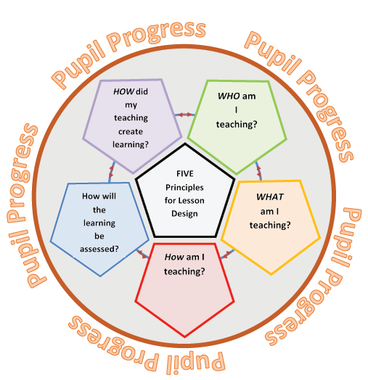
The Five Principles for Lesson Design are framed as questions that you ask yourself as you move around the design process.

The Guidance for Lesson Design that follows is again posed in a question format to prompt the hard thinking required. Although this is written sequentially there is no suggestion that lesson planning is a linear process – far from it. Choose your starting point and move between the sections as required.

Guidance for Lesson Design

Who am I teaching?
- What do I know about my pupils? Consider age, SEND, Most Able, Pupil Premium, EAL, and pupil level assessment data.
- What do my pupils already know (prior knowledge)? How do I find this out?
Evidence of your impact on pupil progress over time
Collect pupil data prior to the lesson to show the starting point. This data needs to reflect the skills, knowledge and understanding that the pupils currently have related to the intended learning outcomes of the lessons you are planning. Examples of where to access this data are: via department tracking systems, through discussions with class teachers and/or TAs, by looking through pupils’ exercise books, using your own observations of the class, discussions with the pupils themselves or via previous formative assessments.

What am I teaching?
- Have I read the long term and medium-term plans used by my school?
The long-term plan could be the National Curriculum Programme of Study, a GCSE specification or a departmental overview of the curriculum.
The medium-term plan could be the departmental ‘schemes of work’.
Some schools may also have short term plans which are a ‘unit of work’ or a sequence of lessons.
- What do I know and what do I need to know about the topic I will be teaching? How will the pupils’ learning be assessed (summatively)?
This is about your own subject knowledge – i.e. do I need to go and research/read/learn an aspect of the curriculum before I can continue planning?
- How do I apply my new or expert subject knowledge to help me interpret the scheme of work? What do we mean by interpreting the scheme of work……..
For more guidance on framing Learning Objectives and Learning Outcomes see Wright, T. (2017) Chapter 5 and Unit 1: Structuring Learning in Pedagogy and Practice: Teaching and Learning in Secondary Schools.
Evidence of your impact on pupil progress over time
Your planning documents should show clearly what you want the pupils to learn. Sometimes there may be gaps in your own knowledge – this is absolutely normal. Subject Knowledge Audits can demonstrate how you have improved your own subject knowledge in preparation for teaching. Lesson observation feedback can focus on how your subject knowledge has impacted upon pupils’ engagement and enjoyment leading to them meeting the learning outcomes.

How am I teaching?
- What teaching models and/or strategies do I think will work best? These may be subject specific.
- What learning tasks match my chosen model/strategy?
- Are these tasks appropriate for my pupils (go back to Who am I teaching? if needed).
- How can I structure my lesson appropriately to match the needs of my pupils?
It is important to stand back at several points during the lesson design process – this is a good point to do that. Have a break and then reassess what you have done so far.

- How does my chosen structure ensure a clear purpose and process for learning?
- What do I need to plan to do or say in between tasks to make the learning explicit? Thinking this through will support you with assessing learning later.
- Do I really understand why I am asking the pupils to do these tasks?
Evidence of your impact on pupil progress over time
Collect samples of pupils’ work, including homework, and annotate to show how your teaching has helped pupils achieve the learning outcomes. Include examples of any interventions you made, for example, changing seating plans, providing revision sessions, use of praise, contact with parents etc. It is useful to take photographs of this ‘evidence’ to share with your mentor.

How will the learning be assessed?
- What are your key questions? Will these questions target specific pupils?
- What responses do you expect pupils to give to your questions and tasks?
- Can you, by considering possible responses, pre-empt possible misconceptions and how you will deal with them?
- As pupils engage with the tasks how do you manage your teacher presence in order to: eavesdrop, circulate between groups, and intervene etc. all of which will allow you to gauge understanding and progress?
- How will you seek feedback on the tasks set?
As you become more experienced you will, at this point in your lessons, be able to react flexibly to unforeseen responses. This is ‘Refection IN Action’ – see Cowan, J. (2006) & Brockbank, A. and McGill, I. (2007).
Evidence of your impact on pupil progress over time
Your annotated and amended planning will demonstrate how you have responded to the pupils’ needs identified via formative assessments. Examples of your marking of pupils’ work and how this was acted on by pupils showing improvements demonstrates the impact of your written feedback. Pupils’ self and peer assessment can be used to compare with your view of their progress. Again keep photographic evidence to share with your mentor.

How did my teaching create learning?
- Did pupils achieve the intended learning through the tasks set?
- How do I know? What evidence do I have?
- Think about the pupils learning behaviours – how did your teaching enable this?
- Relate back to your personal targets (from your Weekly Review or otherwise) and consider to what extent you have met or evidenced them.
Time for another coffee….
By rehearsing your explanation of your progress with your personal teaching targets you are developing the reflective behaviours required to move forward in time for your next Weekly Review meeting with your mentor and to plan your next lesson. This is ‘Reflection ON Action’ – see Cowan, J. (2006) & Brockbank, A. and McGill, I. (2007).

Evidence of your impact on pupil progress over time
Your own lesson evaluation is an essential part of your evidence here. Also, the lesson observation notes from formal observations. Evidence of pupils reflecting on their own learning can be included. Over time test/exam results will support your impact on pupil progress (however, tests are ‘noisy’ measures of attainment and should not be the only evidence offered). Video clips of a lesson or lessons can show individual pupils at the start, middle and end of a sequence of lessons. You could also use audio recordings to ‘voice’ your evidence.

