PebblePad Guide for External Assessors

(Practice Assessors, Mentors, Supervisors)
Please ensure you use Chrome or Firefox browser when accessing PebblePad!

Contents
Logging into PebblePad 1
Accessing students’ work 2
Can’t see/update your student’s work? 2
Filling in External Assessor fields 2
Releasing feedback to students 4
Leaving Additional Comments and Feedback 4

Logging into PebblePad

You will receive notification by email when a student has shared their workbook/ portfolio with you. This will include instructions on how to create your password.
When accessing PebblePad after this you can login directly via https://v3.pebblepad.co.uk/login/worc
…and choose the second option for externals:
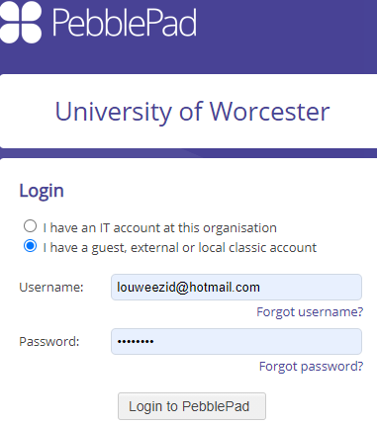
Your username will be the email address that you have provided to us/ your student.
To reset your password, click on the ‘Forgot password?’ link and a password reset will be emailed to you.
There is a video here that will explain the process to you in more detail.

Accessing students’ work
When you are logged in to PebblePad you should see any workbooks/portfolios that have been shared with you:
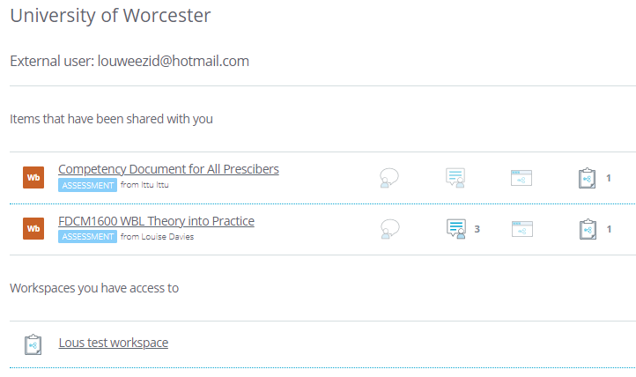
Simply click on the item name to open it.
You will not usually have need to access the Workspaces unless specifically instructed to do so.

Can’t see/update your student’s work?
If you do not see your students work, then please contact the student as they will need to share it with you as an External Assessor share. Make sure you are using your external assessor account rather than any other University of Worcester account you may have used.
If you can view students’ work but are unable to fill in any fields, again please contact the student as they need to share it with you as an External Assessor rather than a personal share.

Filling in External Assessor fields
Usually you will be required to fill in External Assessor fields within the workbook in order to validate and provide feedback on the student’s progress. Assessor fields appear as green boxes with one of three icons:

The Assessor field needs completing and or releasing | The Assessor field has been completed and released | 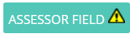  You do not have permission to edit this field (usually for tutors)

Workbook pages will typically look like those in the picture below where you will see a combination of standard form elements like checkboxes and text boxes:

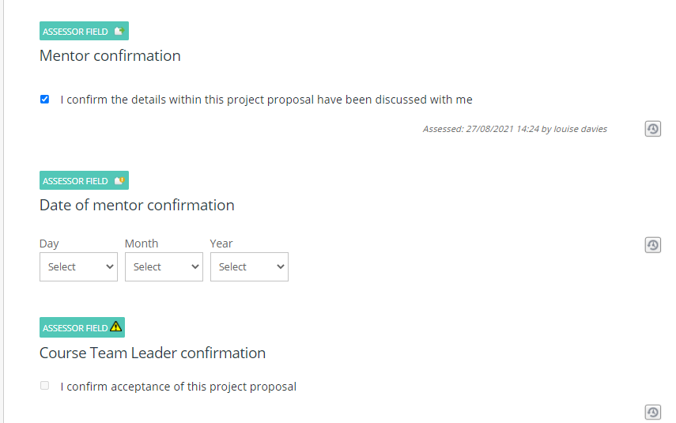
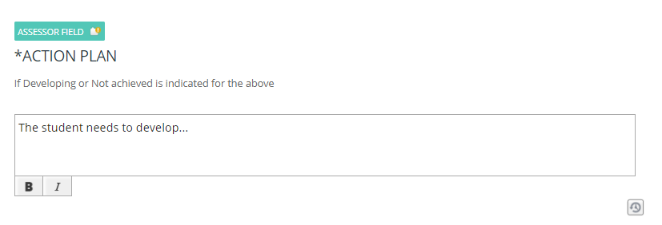
Students may have added files as links or as evidence to their workbook/ portfolio. If they have added evidence, you can view this by clicking on the drop-down arrow where you see an evidence rosette:
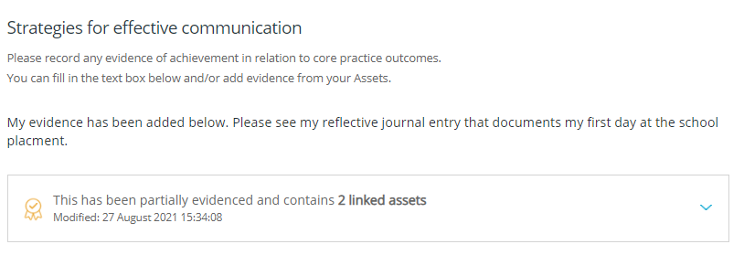
Then you will see the evidence files:
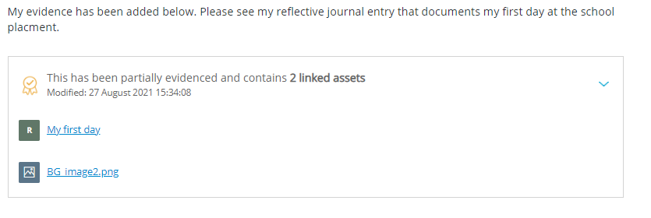
Files will open in a new tab or window.

Releasing feedback to students
You will need to save your feedback on each page of the workbook/ portfolio. At the bottom of each page that has an assessor field you will see a checkbox that allows you to release the feedback to the student.
If you check ‘Release assessor field feedback now’ and click on Save, the student will see what you have completed.

Leaving Additional Comments and Feedback
On every page you will also see the blue assessor’s toolbar on the right-and side.
Generally, you will not need to use this unless instructed to do so. Here are what the icons mean just in case:

