Introduction
The University of Worcester takes a ‘whole university’ approach to sustainability, from the development of its curriculum to the purchasing of goods and services, research and consultancy and has mapped its work to the SDGs through the publication of its annual review, clearly demonstrating its commitment and support for social responsibility, environmental sustainability and carbon emissions reduction to its students, staff and to the wider community.
Each year, the University’s Sustainability team runs a number of campaigns and activities, with targets mapped against set baselines, to achieve effective engagement with students, staff and the wider community.
Effective communication leading to higher levels of engagement is the key to both behaviour change and continuing support for the sustainability agenda.
This report sets out how well some of those activities have performed in the 2024/25 academic year and should be read in conjunction with the Communications and Engagement Plan.
Knowledge & Training
The Climate Emergency is arguably the most serious global issue we are currently facing; however, individuals often feel that they lack the knowledge or confidence to effect change.
In 2024, the university asked students and staff about sustainability knowledge and awareness, as part of a longitudinal study. Student awareness from survey data over the following 6 categories: energy, travel, food, carbon, biodiversity, and Sustainable Development Goals equals 66%. Our target is for the University’s sustainability activities to increase from 47% in the baseline year of 2016/17, to 65% by 2025, which means we have reached this, which is pleasing.
You can read more about the student surveys here: https://susthingsout.com/sustainability-a-student-perspective/ and https://susthingsout.com/student-sustainability-skills-survey-2024/, and https://susthingsout.com/green-skills-and-careers/
Staff were increasingly aware of efforts to embed sustainability in the curriculum, with 49% being aware and either very or somewhat engaged. You can read more about the staff survey here: https://susthingsout.com/staff-sustainability-culture-in-2024/.
In 2021, the University began delivering Carbon Literacy Training aimed at staff, students, and partners. The course offers participants the chance to learn in-depth knowledge about climate change and discover ways to change their behaviour. We had a DESNEZ grant to deliver this using our students and co-trainers to deliver this across Worcestershire, in a partnership with the Open University. One project delivered this in libraries in Worcestershire https://susthingsout.com/carbon-literacy-worcestershire-libraries/
In addition, the University ran the eighth Sustainable Development Goals (SDG) Teach-In, raising awareness of the SDGs throughout March 2025. 30 educators pledged to reach approximately. 2289 students – 25% of the student body. (2024 29 educators pledged, reaching 1628 students – 17% of the student body. (2023) 41 educators pledged, reaching 4374 students – 48% of the student body. There remains good engagement in terms of embedding the SDGs; it appears that setting up an ESD Community of Practice would serve to showcase good practice and enhance Teach-In participation.
Travel
The University conducts annual travel surveys with both staff and students to inform its Sustainable Travel Plan and to communicate with each other about ways to travel more sustainably. The survey provides an opportunity to remind staff and students about active travel schemes. We have established a new Steering Group to help us make more of an impact in this area. More information is on our transport and travel page.
Student Jake has created infographics summarising our travel data, which included information about commuter students asked in the first few weeks of the semester. View the results here
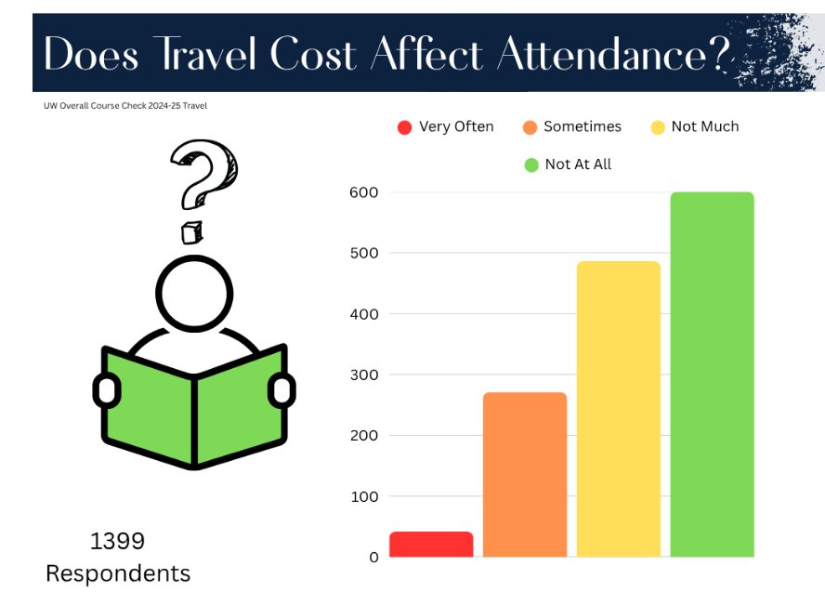
Digital Engagement
The www.susthingsout.com is a central repository for all the University’s sustainability work and news. It is currently managed by the University’s Director of Sustainability, with input and most of the content created by students. Many of the posts are shared across the University’s main social media channels as well as an Instagram and a fledgling TikTok account.
Analytics tells us that some of these student-created posts are well-read and engaged with. The site has been going for over 10 years, and some of our very oldest posts are still very popular with the local and University communities. The site is continually revamped and refocused.
The University’s main website worcester.ac.uk is primarily aimed at prospective students. There are specific pages on sustainability, listing many of the University’s achievements, to inform prospective students, current students and stakeholders about the University’s commitments.
About Sustainability consistently gets around 1500 page views, and transport and travel, waste, carbon targets, and sustainability achievements get the most views.
Press coverage
News about sustainability events and activities is regularly shared via the University’s Press Office with local media. This is a useful tool for engaging with external audiences, sharing messages of best practice, and aiming to inspire others to continue to take on the sustainability baton.
In 2024/25, many articles were published in the media about the University’s sustainability credentials, and work increased, with more interest from the public in sustainability, we feature regularly in local and national media. See our Press pages.
Awards and achievements
Details about our latest achievements can be found on this page.
July 2025

