|  |  |
| --- | --- |
| 2D_colour_72dpi | j0293236 |
| Registry Services  Briefing Note: RS/10/02 | Any enquires should be directed to:  Sally Dobbins,  Assistant Registrar, Student Records |

**Uploading Feedback**

Registry Services are piloting an e-feedback system that allows tutors to upload assessment feedback via staff SOLE. Once published, students will be able to download their feedback via SOLE. This document will outline the procedure necessary to upload feedback and will give a brief outline of the method used by students to retrieve the document.

Assessment markers that have enrolled in the e-feedback pilot will have a new link available on their SOLE page entitled ‘*Upload Feedback*’. This can be accessed from within the ‘*Feedback*’ container in the ‘*Staff Home Page*’ section of SOLE, as illustrated below.

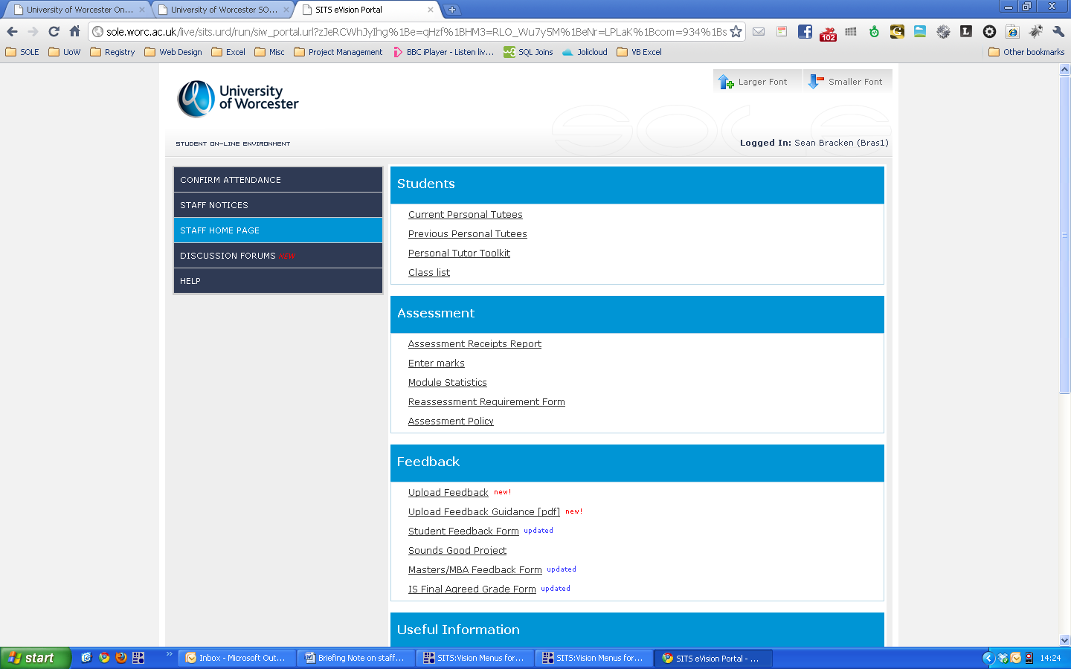

Once clicked, the tutor/marker will be presented with a list of their modules. If a module is not present on the list, the user must contact [solehelp@worc.ac.uk](mailto:solehelp@worc.ac.uk) or the relevant administrator in Registry, quoting their user ID, to be added as a marker to the module.

There are a number of options available on the page, as shown below, that allow the user to either:

* Publish or delete feedback that has already been uploaded by clicking the ‘*Go to Publish/ Delete Feedback...*’ button
* Select a new module to upload feedback against by clicking the radio button from within the list of modules.

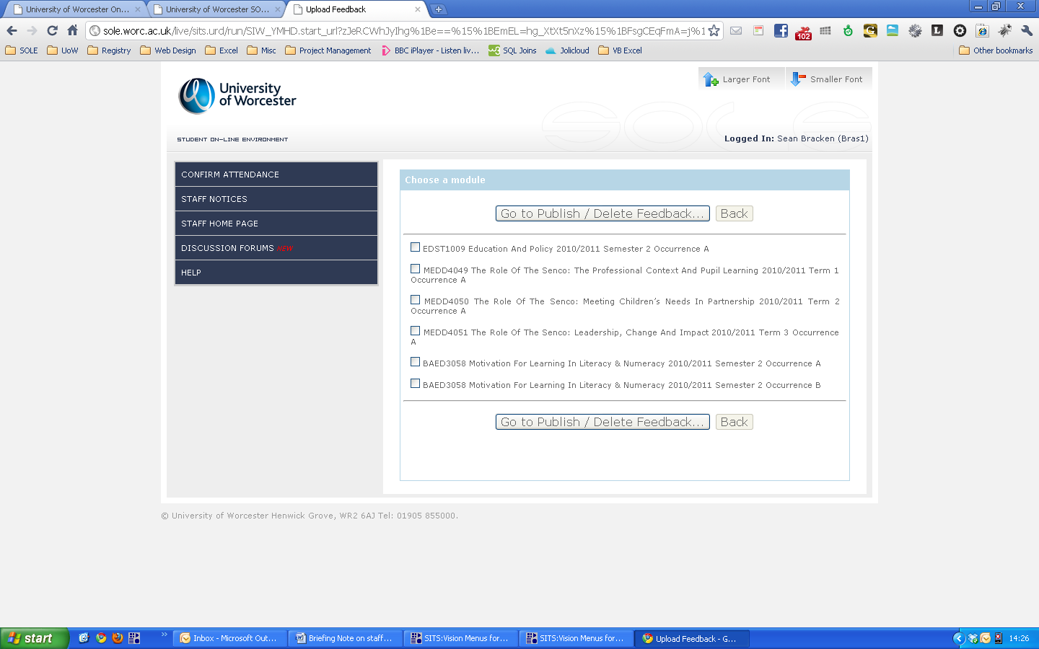

When the user clicks an option from the list of modules, the next page will automatically load. If this doesn’t happen, you may need to enable JavaScript in your browser (for instructions on how to do this please visit <https://www.google.com/adsense/support/bin/answer.py?answer=12654>).

The user is then presented with a list of the assessments for the module they previously selected. As before, selecting an option will automatically navigate the user through to the next stage of the task. The user is also given the option of going back to the previous step by clicking the ‘*Back*’ button.

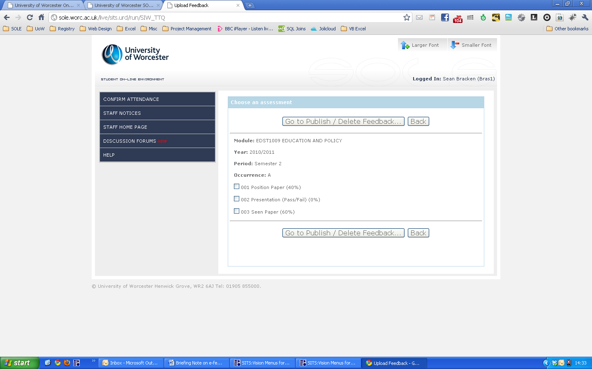

Having clicked an assessment, the user is presented with a list of students that are registered on the chosen module. There are two columns on the page; the first column (*Waiting*) shows a list of students and whether their assessment has been receipted or not, as indicated by a tick or cross. The second column, ‘*Uploaded*’, displays a list of student numbers/names that have had feedback uploaded against their assessment.

At this stage, whether there are student names/numbers listed in the ‘*Uploaded*’ column or not, no feedback is available to students, as it has yet to be published/confirmed.

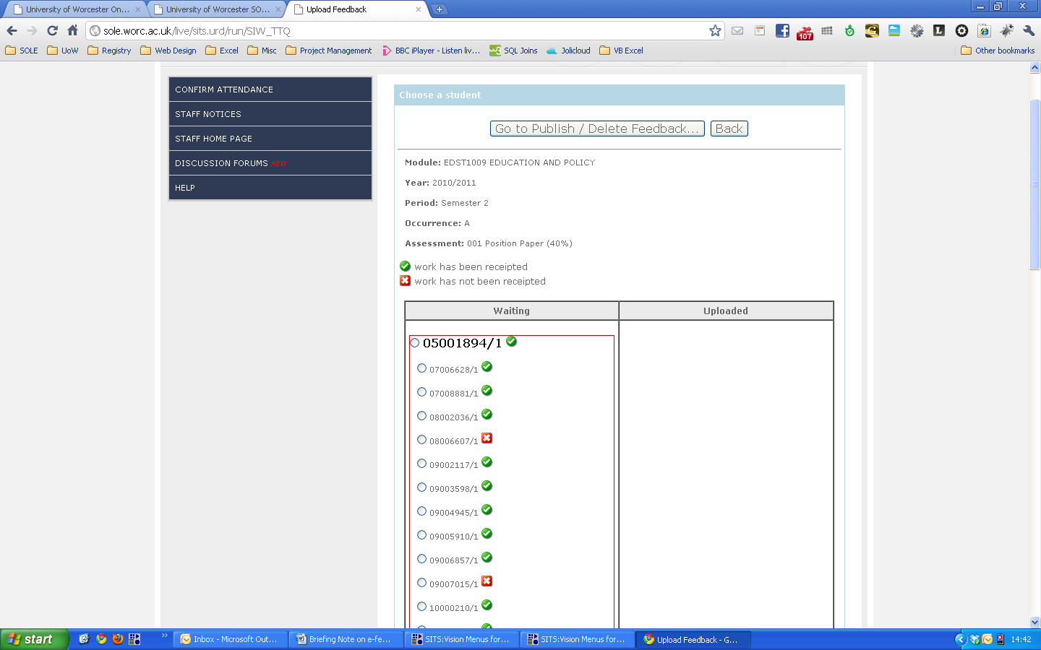

On selecting a student from the list, the user is taken directly to the upload page shown below. Clicking the ‘*Choose File*’ button opens the file explorer and allows the user to select the feedback document from their PC.

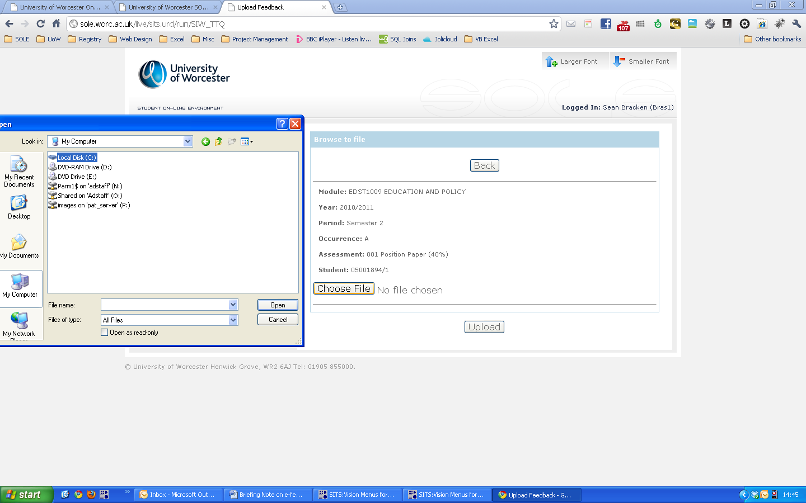

Once a file has been selected and the user has clicked ‘*Open*’ in the file explorer, the document name will appear next to the ‘*Choose File*’ button. At this stage, the user can either go back to the student selection screen by clicking the ‘*Back*’ button, or upload the document by clicking the ‘*Upload*’ button.

Once each student has been selected and a document uploaded, all student names/numbers will be listed in the ‘*Uploaded’* column. The document can be downloaded by clicking on the link next to the student name/number.

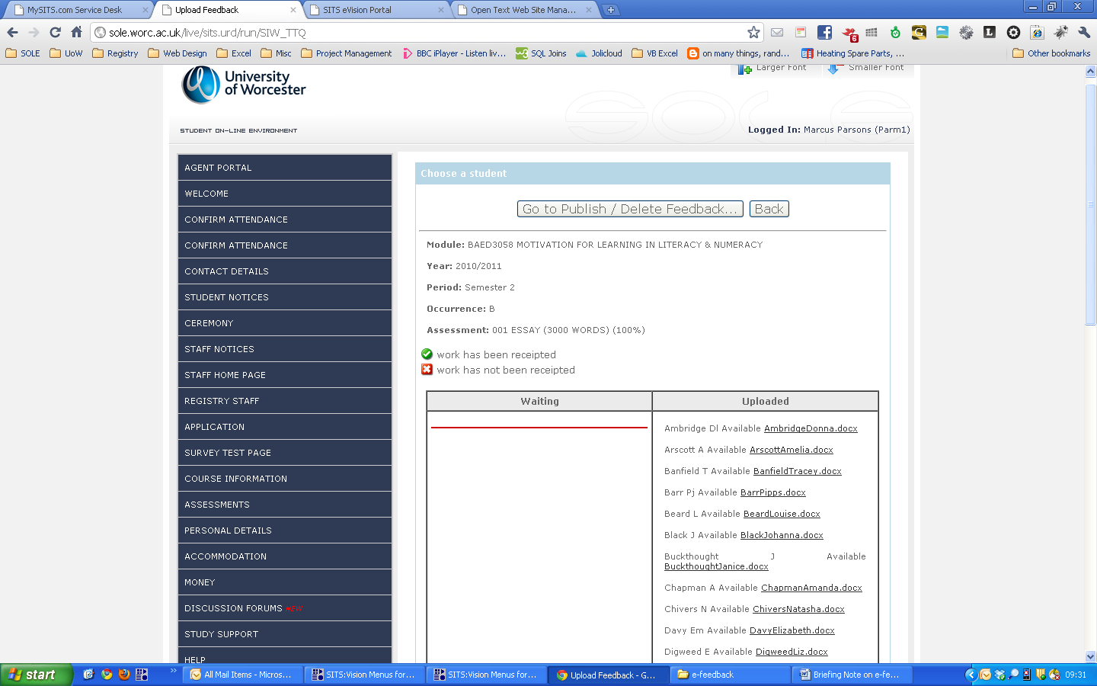

By clicking ‘*Go to Publish/Delete Feedback...*’ the user will be presented with the following screen. A list of student numbers/names will be available to select and the user can publish or delete feedback by clicking the appropriate button on the page:

